'Programmer: Samantha Naini
'Exercise: 5-3-11
'Date:4/23/2012
'Program Purpose: Calculating pay raises by entering an original salary.

Option Strict On
Option Explicit On

Public Class frmPayRaise

Private Sub btnDisplay_Click(ByVal sender As System.Object, ByVal e As System.EventArgs) Handles btnDisplay.Click
Dim firstName As String = ""
Dim lastName As String = ""
Dim salary, newSalary As Double

InputData(firstName, lastName, salary)
newSalary = RaisedSalary(salary)
DisplayOutput(firstName, lastName, newSalary)
End Sub

Sub InputData(ByRef firstName As String, ByRef lastName As String, ByRef salary As Double)
firstName = txtFirstname.Text
lastName = txtLastName.Text

If IsNumeric(txtCurrSalary.Text) Then
salary = CDbl(txtCurrSalary.Text)
End If

If salary = Nothing Then
MessageBox.Show("Please enter a valid number.")
txtOutput.Text = " "
End If

If firstName = Nothing And lastName = Nothing Then
MessageBox.Show("Please enter a name.")
txtOutput.Text = " "
End If
End Sub

Function RaisedSalary(ByVal salary As Double) As Double
If salary <= 40000 Then
Return 1.05 * salary
Else
Return salary + 2000 + 0.02 * (salary - 40000)

End If
End Function

Sub DisplayOutput(ByVal firstName As String, ByVal lastName As String, ByVal newSalary As Double)
If firstName = Nothing And lastName = Nothing And newSalary = Nothing Then
txtOutput.Text = ""
Else
txtOutput.Text = "New salary for " & firstName & " " & lastName & " is: " & FormatCurrency(newSalary) & "."
End If
End Sub

Private Sub btnClear_Click(ByVal sender As System.Object, ByVal e As System.EventArgs) Handles btnClear.Click
txtFirstname.Clear()
txtFirstname.Focus()
txtLastName.Clear()
txtCurrSalary.Clear()
txtOutput.Clear()
End Sub

Private Sub btnEnd_Click(ByVal sender As System.Object, ByVal e As System.EventArgs) Handles btnEnd.Click
If MsgBox("Do you really want to quit?", MsgBoxStyle.YesNoCancel, "End Program") = MsgBoxResult.Yes Then
MsgBox("have a great day! =)")
Me.Close()
End If
End Sub

End Class
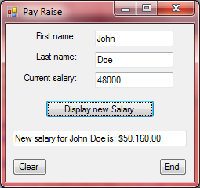
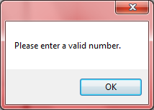 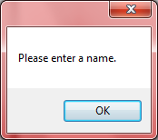← If fields are left blank
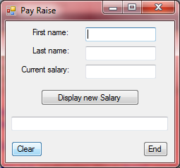←Clear button
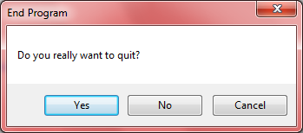 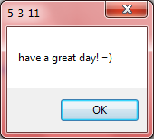←End button
'Programmer: Samantha Naini
'exercise: 5-3-12
'Date: 4/23/2012
'Program Purpose: Calculating new balance and minimum payment on a credit card.

Public Class frmCreditCard

Private Sub btnCalculate_Click(ByVal sender As System.Object, ByVal e As System.EventArgs) Handles btnCalculate.Click
Dim OldBal As Double
Dim Charges As Double
Dim Credits As Double
Dim NewBal As Double
Dim MinPayment As Double

OldBal = CDbl(txtOldBal.Text)
Charges = CDbl(txtCharges.Text)
Credits = CDbl(txtCredits.Text)

'calls the function and sub procedures:

'sub InputData
InputData(OldBal, Charges, Credits)

'function CalculateNewValues
CalculateNewValues(OldBal, Charges, Credits, NewBal, MinPayment)

'sub DisplayData
DisplayData(NewBal, MinPayment)

End Sub

Sub InputData(ByRef OldBal As Double, ByRef Charges As Double, ByRef Credits As Double)
OldBal = CDbl(txtOldBal.Text)
Charges = CDbl(txtCharges.Text)
Credits = CDbl(txtCredits.Text)

End Sub

Function CalculateNewValues(ByRef OldBal As Double, ByRef Charges As Double, ByRef Credits As Double, ByRef NewBal As Double, ByRef MinPayment As Double)

NewBal = OldBal - Credits + Charges + (OldBal * 0.015)

MinPayment = 0.015 * OldBal

If NewBal <= 20 Then
MinPayment = NewBal
Else
MinPayment = 20 + (0.1 * (NewBal - 20))
End If

End Function

Sub DisplayData(ByRef NewBal As Double, ByRef MinPayment As Double)

Dim OldBal, Charges, Credits As Double

OldBal = CDbl(txtOldBal.Text)
Charges = CDbl(txtCharges.Text)
Credits = CDbl(txtCredits.Text)

txtNewBal.Text = "" & FormatCurrency(NewBal) & ""
txtMinPayment.Text = " " & FormatCurrency(MinPayment) & " "
End Sub

Private Sub btnClear_Click(ByVal sender As System.Object, ByVal e As System.EventArgs) Handles btnClear.Click
txtOldBal.Clear()
txtOldBal.Focus()
txtCharges.Clear()
txtCredits.Clear()
txtNewBal.Clear()
txtMinPayment.Clear()
End Sub

Private Sub btnEnd_Click(ByVal sender As System.Object, ByVal e As System.EventArgs) Handles btnEnd.Click
If MsgBox("Do you really want to quit?", MsgBoxStyle.YesNoCancel, "End Program") = MsgBoxResult.Yes Then
MsgBox("have a nice day!")
Me.Close()
End If
End Sub
End Class
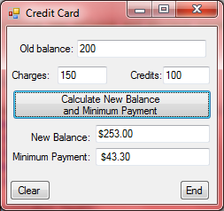 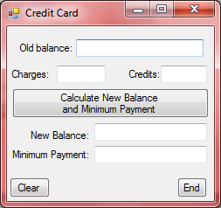←clear button
